(Approx. 576 words)

Searching for Solutions to Computer Problems
Tom Burt, Vice-President
Sun City Summerlin Computer Club
https://www/scscc/club
tomburt89134 (at) cox.net

A while back, I was diligently working on the weekly meal plan and shopping list for our happy household. I do this by copying the previous week’s plan and editing it while reviewing the online versions of the local supermarket weekly ads. My meal plan Word document has two columns: one for the menus and one for the shopping list. Here’s a screenshot …
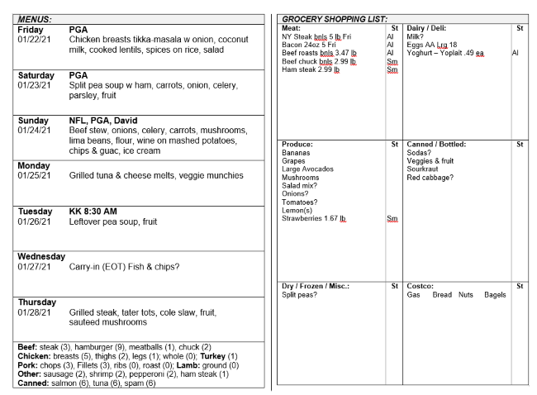
The exact details don’t matter. I use Word tables for the two columns. This document has worked fine for several years.

I was working on it last week and, suddenly, when I tried to place the Word cursor at a location within the table so that I could type in some changes, the cursor simply could not be placed anywhere inside either table. All the tools in the ribbon were clickable. I saved and closed the document and Word. When I reopened the document, the cursor worked properly for a bit until I clicked something outside the table; then once again I couldn’t place it anywhere inside the table. By repeatedly closing the document and reopening it, I was able to finish the meal plan, print it, and hand it off to Mrs. Burt, so she could plan out her weekly shopping expedition. However, this was not going to be viable long term.

Later that day, I decided to search the web to see if others had experienced this problem. I used Google and entered word 365 won't accept cursor in table as my search word set. The search produced 600,000 hits! I browsed through the first page of search results and the 5th item down from the top was the following:
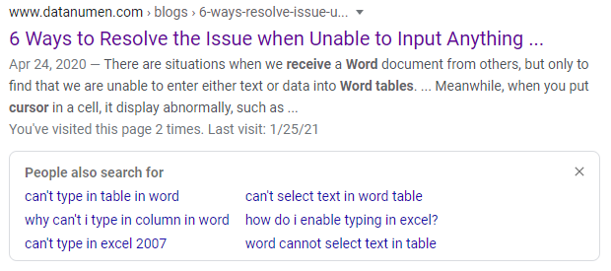
This article included a suggestion that if I had set explicit row heights in the table (I had), that I remove those row height settings. I tried that and “voila!”, the problem with placing the cursor went away. I then reset the row heights in the tables to their former values and saved the document. After this, I had no trouble placing the cursor anywhere on either table.

So, it appears that my Meal Plan spreadsheet in some subtle way had become corrupt or triggered some latent bug in MS Word. The “fix” (really a hack) worked, so I’m happy. However, I would never have thought to try that fix because that document had worked fine for years.

The moral of this story is that, when you encounter bizarre behavior in Windows, Office, or other applications, don’t beat yourself up. Once you’ve tried the simple, obvious things without success, it’s time to fire up your favorite search engine (Google, Bing, DuckDuckGo, …) and see what suggestions others might have to offer.

The key to success is in the phrasing of your search terms. If an error message is popping up, use that error code as one of your search terms. Be as specific as you can to narrow your search results to ones likely to be related to your problem. Include the name and possibly the version of the program as a search term. If you don’t get an answer with one set of search terms, try varying the terms with synonyms. Try being a bit more (or less) specific. And don’t give up after reviewing the first page of results; sometimes the real gems are further down in the result list.

